DIGITAL LIBRARY

Purushotham A, Maka Gopi Raju, Palagiri Naveen Reddy, Tadigotla Kranthi Kumar Reddy , Undela Praveen Kumar Reddy

1Associat Professor Department of ECE, Hindusthan Institute of Technology, Coimbatore, Tamil Nadu, India.

2,3,4,5 Student Department of ECE, Hindusthan Institute of Technology, Coimbatore,

Tamil Nadu, India.

Abstract- Over the last three decades an innovation have helped the early realization of digital libraries to become a truth. Digital libraries are fetching a vital part of digital education age. Their active role is increasingly becoming an action of the library’s part to the rebellion and maturing of a group and the nation at large. A digital library that distributes with data those are regular digital as well as those that have been compute from their equivalent form. The aim of this paper is to debate services and involvement of digital libraries in the information age. It constitute basic concepts,factualenvironment,componen ts,characteristics,activity,advantages, and disadvantages in digital conditions

KEY WORDS: JAVA, SQL, KADANS, BRUTFORCE, JDK, JAVASCRIPT

1. INTRODUCTION

Digital libraries provide users with online access to a wide range of resources. They are always utilized by graduates for tested or by officials searching to maintain present on the new developments in their field.

virtual book store can improve students with allow to sparse and un available substence that might be hard or out of the question to locate in physical libraries

virtual book stores also offer a various of seeking and making features, as well as social media-like features that can connect persons with others to discuss concepts.

As digital book store peruse to develop, advance features such as interactive media text, data graphics tools and interactive bilateral are being adding to software to make digital libraries even more seize and obliging.

2. LTTERATURE SURVERY

In a study direction by Asad Khan (2021), the factors that influence research students' approval of digital libraries were analysis. The research revealed that the interface attribute play a crucial role in affecting corporeal response, which, in turn, predicts the design to use digital libraries. The ease of use of digital libraries is changed by navigation, individual disparity, and system characteristics, whereas the versatility is impacted by system aspect and characteristics. The study also begin that usefulness has the most significant effect on the motive to use digital libraries

Another class by Xianjin et al (2019) investigated the flow maturity of users with mobile libraries and net digital libraries. The flow experience is decided as the optimal experience obtained by consider perceived skills and challenges. The research invented those users professional more flow while using web automated libraries than mobile libraries.

Customer churn rate was the target of a study by Yuangen and Zeng (2020). The prospect churn rate is careful as the rate of customer discontinuation. The study begin that the customer churn amount of the given library was high, with the highest churn hazard appear within the initial three months later a customer's enrolment on the library's web site.

Yalan et al (2022) instruction research on the quality of digital libraries, whichever is defined as the affection of information, system, and total service. The study aimed to compare users' concept of digital libraries and virtual communities to explain the actual nature of grasped e-quality. Based on users' perceptions, the study found such digital libraries provide improved information, system, and service quality than implicit communities.

Overall, the evolution of information technology has led to compelling changes in society by permissive the archiving and access of awareness in digital format. While the appeal for electronic information is increasing, common library formats are becoming more executive and challenging to manage. To fair the expectations of digital users, libraries need to repeat their services to add value and build customer satisfaction.

3.PROPOSED SYSTEM:

The initial degree of developing a library system involves collection requirements. This process entails understanding the want of the library, which includes revealing the resources that need to be made possible and the requirements of the users. Library staff, contributor, and end-users may be consulted during this phase to regulate the critical features and purpose that the system become provide

4.PROPOSED METHODOLOGY:

The system appears to be notable to store and process data relevant to books, with separate division for student and admin cases. It is capable of charge large amounts of data, with a processing

quantity of at least 25GB. This suggests that the system is intended to shaft a significant amount of information, like in a full library or other educational service.

The system is designed to use Java bounden data to growth input from users in real-time rundown. This advance that the system is intended to be interactive and responsive, tolerant users to access and shap data in real-time.

To ensure the certainty of the data, sensors are equipped within each book to align the accelerometer's pivot and assure that the response of acceleration data is accurately stated. This express that the system is intended to path and guide the evolution of books, likely for purposes such as tracking reserve or ensuring that books are repaid to their fitting location.

5.BLOCK DAIGRAM:

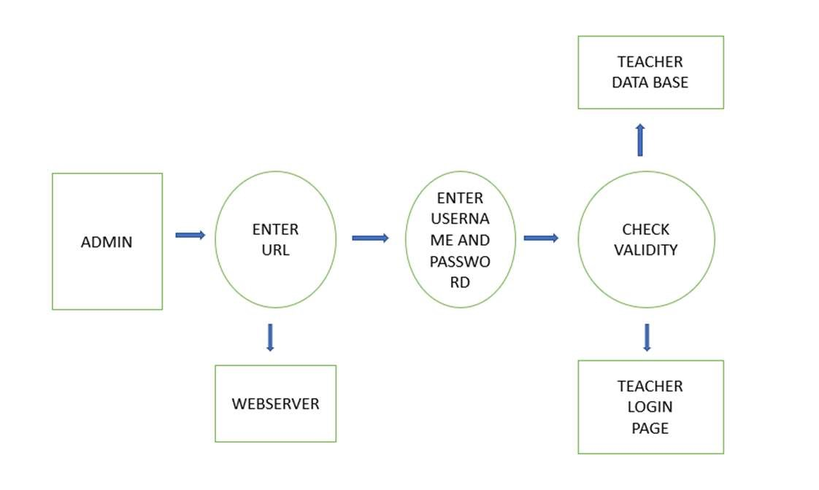

Figure-1: Block Diagram of visualization

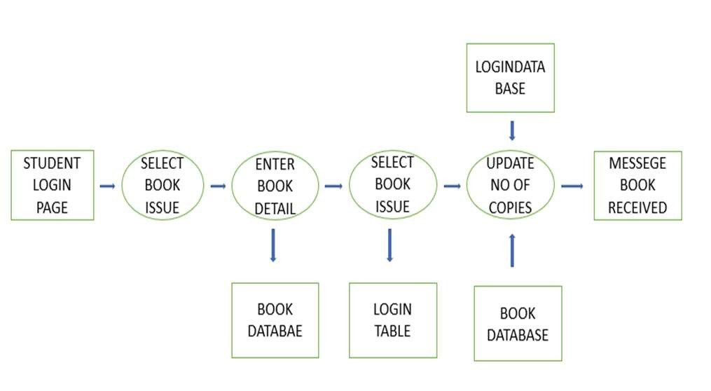

Figure-2: Block Diagram of Book storing

6.FLOW CHART:

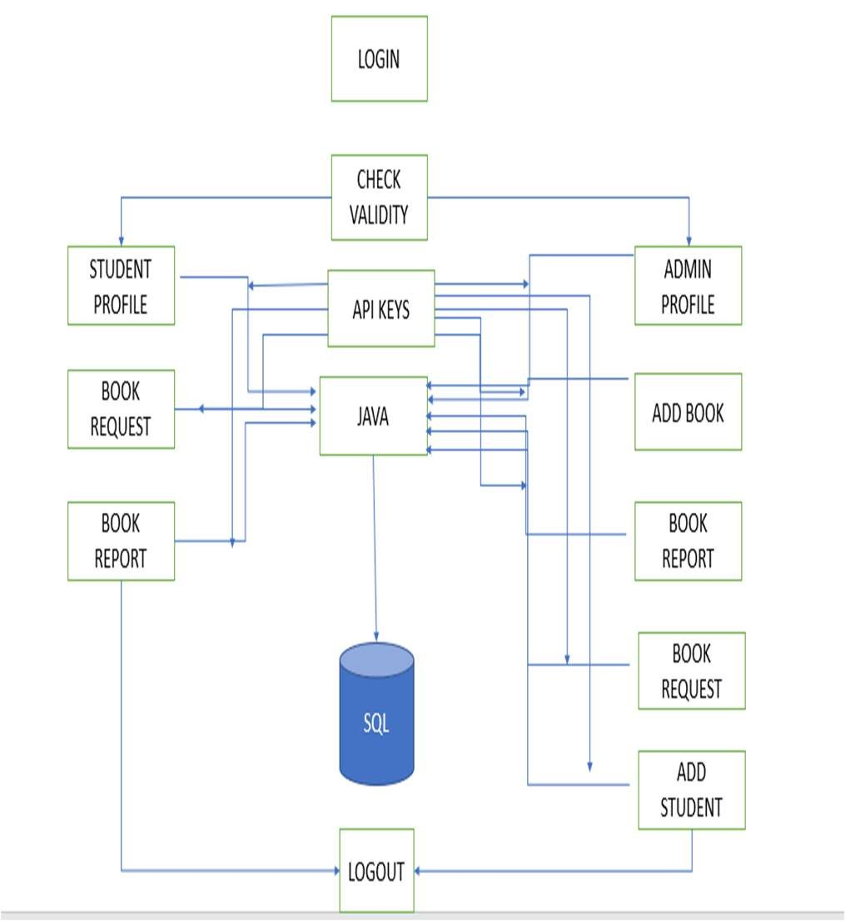

Figure -3: Flow Chart

7. SOFTWARE REQUIREMENTS:

Windows 10 is the current set off system that is recommended to use as it has upgrade features, better performance, and is more fixed. It also receives regular refurbish from Microsoft to ensure that it remainder up-to-date with the latest security smudge and features.

There are other operating systems accessible, such as macOS and Linux, which may be finer suited to define needs or predilection



Figure- 4: Windows 11

By using the MYSQL we can store the book records and merging them by using the respective algorithms

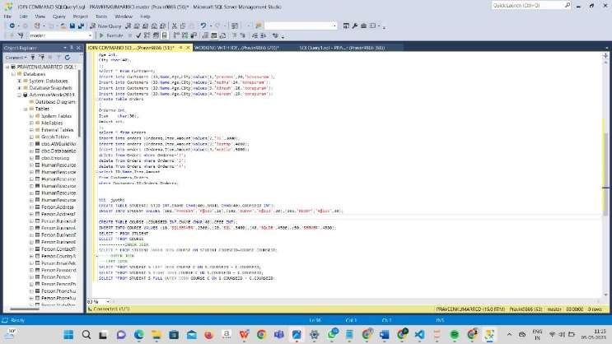

Figure-5: Data Base storage

Development tools and Programming language

HTML

CSS

JAVA

SQL

JAVA SCRIPT

REACT.JS

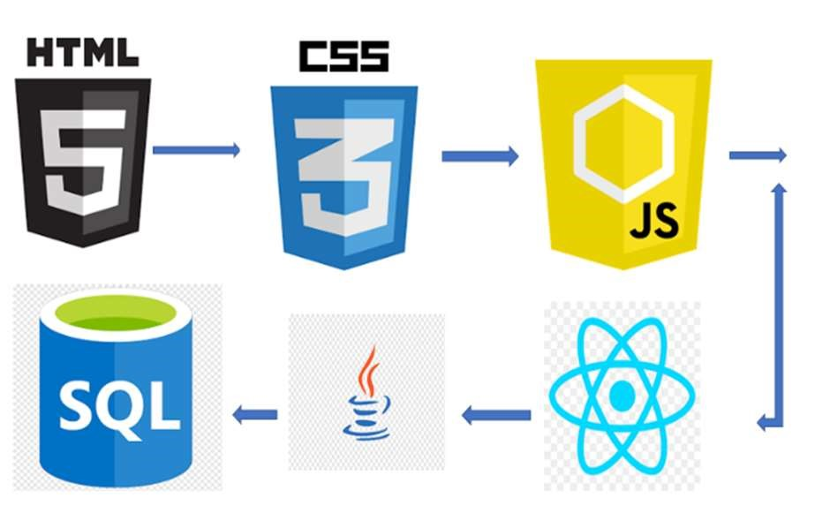

Figure-6: Tools

Open access to information, vast content collection will be available with opensource software tools and new method will be initiated of digital preservation. There is various software which are used for creating digital libraries, used by users. It is important to know the requirements of different class of user, and for that evaluation of various software’s used for creating digital libraries is necessary. The software should be studied on the basis of that for which user community it is developed

REQUIREMENT TOOLS

* VS CODE
* ECLIPSE
* MSSM

8. HARDWARE REQUIREMENTS:

1. Intel core i5 processor

Intel core I5 2nd generated version is needed as a processor because it is efficient than any other cores an justify efficient and perfect and we can execute our system for long time. By utilizing this processor, we can take on enveloping our project without any issues.

1. Ram 1 Gb

Random Aces Memory of 1 gigabyte is needed as it can establish efficient blogging and writing capabilities and would in support.

9. IMPLEMENTATION OF THE LIBRARY

Consider the motive sweep of your library: Pick on the performance and article that your library will contribute.

Proposal the construction: Plan the construction of your media centre. Proposal on the Organize language, tools, and scheme will use.



Figure 7: Database Storing

10 RESULT

The outcome of the servers bring the latest details of the books access, integrate, storehouse and delude data will gets brand-new.

Add after together the hand full of books and few users data will get brand-new in the develop application

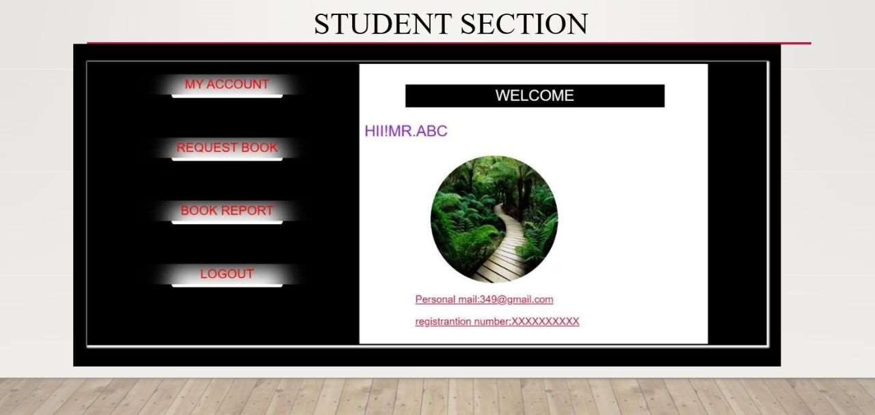

Figure 8: student and admin section

11. CONCULSION

Virtual libraries are not going to describe the physical form of charter completely but no indecision connect the current requirements, to gratification the unknow user computerize must be implemented so that at tiniest libraries becomes of hybrid culture.

The precost of computerize is high but demonstration shows that once computerize is establishment then the cost to maintain this pre request were be lesser than that of any conventional library.

On the daily bases the cost of computerization

is Reducing, the online reporting is increasing, the necessity of user are convey with regards a different natural world so it's unwanted to say that after three or four years my library or your library will go to be computerized so it’s the pick time to all enlightenment and library executive that they adopted themselves to take the stand against.

12. FUTURE SCOPE

Departing digital repository services are in an give off stage, according to an look at there are more than 900 repositories open approach rushing. There are more open origin software which are pleasant in making open access repositories. As a outcome of which more libraries were combine in generate institutional repositories or digital libraries So, it has many digital repositories in nearby later. Open access to information, vast content group off will be obtain with opensource software tools and new system will be initiated of digital preservation.

REFERENCE :

[1]. R. Kavya, P. Jemiah, “Digital Library Using KOHA”, JETIR February-2022, Volume-8,

Issue-4.

[2]. Sankar Narayanan R, Saravana Kumar M, Nishanth M, Saran raj K, Sujay K, “Automobile Black Box System for Vehicle Accident

Analysis”, International Research Journal of

Engineering and Technology (IRJET) Volume7, Issue-3, 2022.

[3]. P. Ardra, Ayisha, Ayisha Shawkat, M.R. Sruthy, “Automobile Black Box for Accident Analysis”, International Journal of Research in Engineering, Science and Management, Volume -3, Isuue-4, April-2022.

[4]. Vidya Deshmukh, Mahesh Ghate, Akanksha Sukre, Pramila Shined, “Accident Detection and Monitoring using Black Box”, SAMRIDDHI Voiume-12, Special Issue-2,2020.

[5]. Wagle Mahesh Nanubhai, DR. Kharat Govind Khadra, “Wireless Black Box of

Accidental Monitoring of Vehicles using MEMS Accelerometer, GSM and GSM Services”, JETIR June-2019, Volume-6, Issue-6.

[6]. Abinaya. V, D. Dhana Sekar. A, Hari Prasath

R, Dinesh Kumar. M, “Development of Wireless Black Box Using MEMES Technology for Accident Prevention”, South

Asian

[7]. Vikas J. Desai, Swathi P. Nawala, Sachin

R. Kokane, “Design and Implementation of

GPS and GSM Based Accident Detection

System”, International Journal of Technology

and Science Sep 2014.

[8]. Ms. Priti J. Rajput, Prof. D. U. Dakar, Prof. S. R. Subalar, “Can Communication

Based Accident Emergency Supervisory

System”, International Journal of Advanced Research in Electrical, Electronics and Instrumentation Engineering April-2013.

[9]OPALS is another open-source automated digital library software that is trustworthy, easy to afford, implement and use. Many libraries across the world are using OPALS to manage their digital libraries which is a reason enough to know more and try it.

[10]Witten, Ian H.;

Bainbridge, David Nichols (2009). How to Build a Digital Library (2nd ed.). Morgan Kaufman. ISBN 9780080890395.

[11]Lanagan, James; Smeaton, Alan F. (September 2012).

"Video digital libraries: contributive and decentralized". International Journal on Digital Libraries. 12 (4): 159–178. doi:10.1007/s00799-012-0078-z. S2CID 14811914

[12]Schatz, Bruce (1997).

"Information Retrieval in digital Libraries Bringing Search the Net". Science. 275 (5298):

[13]Wiederhold, Gio (1993).

"Intelligent integration of information". ACM SIGMOD Record. 22 (2): 434– 437. doi:10.1145/170036.170118

[14]Schatz,Bruce(1996).Chen, his

"Building large-scale digital libraries". IEEE Computer. 29 (5): 22– 25. doi:10.1109/2.493453. hdl:10150/106127.

[15]Isah, Abdulmumin; Serema, Batlang Comma; Mutshewa, Athulang; Kenosi, Lekoko (2013).